An AI-Based Career Guidance System for Kenyan High School Graduates

Student No: 151438
Group: C

An Information Systems Project Proposal Submitted to the School of Computing & Engineering Sciences in partial fulfillment of the requirements for the award of a Degree in Business Information Technology

Date of Submission: May 2025

Declaration
I declare that this work has not been previously submitted and approved for the award of bachelor’s degree by this or any other University. To the best of my knowledge and belief, the proposal contains no material previously published or written by another person except where due references are made in the proposal itself.

Student’s signature:

✍…………………………………………………………………[Signature]

✍………………………………………………………………..[Date]

Abstract
Career guidance is essential in shaping students’ academic and career futures. In Kenya, most high school students complete their studies without access to educative career advice, especially those in rural areas where career counseling resources are limited. This often leads to poor course selection, dissatisfaction and high dropout rates in universities and colleges. To address this challenge, this project proposed the development of a web-based AI Career Guidance System specifically for Kenyan high school graduates. The system used Artificial Intelligence and basic machine learning algorithms to recommend suitable career paths and university programs based on students’ KCSE results and personal interests. The platform offered a user-friendly interface for both students and school counselors to interact with, ensuring accessible, data-driven career recommendations. The system was designed to enhance the decision-making process and provide real-time support, reducing the mismatch between student capabilities and academic paths. The development approach followed the scrum methodology and Object-Oriented Analysis and Design to structure system components for reusability and scalability. Technologies used included HTML, CSS, MySQL and Jupyter Notebooks for model training. In conclusion, this project bridged the gap between academic performance and career choices by providing an efficient solution to improve academic and professional outcomes for Kenyan students.

Table of Contents

Declaration ii
Abstract iii
List of Abbreviations viii
Chapter 1: Introduction 1
1.1 Background Information 1
1.2 Problem Statement 2
1.3 Research Objectives 2
1.3.1 General Objectives 2
1.3.2 Specific Objectives 2
1.4 Research Questions 2
1.5 Justification 3
1.6 Scope and Limitations 3
1.6.1 Scope 3
1.6.2 Limitation 4
Chapter 2: Literature Review 5
2.1 Introduction 5
2.2 The Career Guidance Process in Kenyan High Schools 5
2.3 Challenges Affecting Career Guidance in Kenyan High Schools 6
2.3.1 Inadequate Training and Proficiency Among Teachers 6
2.3.2 Limited Access to Career Information and Technological Resources 7
2.3.3 Parental and Peer Pressure on Career Choices 7
2.4 A Review of Existing Solutions 8
2.4.1 CareerCoach by Microsoft 8
2.4.2 MyCareerCompass- South Africa 9
2.4.3 CareerVillage 9
2.5 Gaps in Existing systems: A consolidation of all the disadvantages in existing Systems 10
2.6 Technologies 10
2.6.1 Artificial Intelligence (AI) and Machine Learning (ML) 10
2.6.2 Natural Language Processing (NLP) 11
2.6.3 Web Development Technologies 11
2.6.4 Database Management Systems 11
2.7 Proposed System 11
2.8 Conceptual Framework 12
Chapter 3: System Development Methodology 14
3.1 Introduction 14
3.2 System Development Methodology 14
3.2.1 Sprint 1 – Requirements Analysis 15
3.2.2 Sprint 2 – System Design 15
3.2.3 Sprint 3 – Development of Core Modules 15
3.2.4 Sprint 4 – AI Model and Recommendation Engine 16
3.2.5 Sprint 5 – Testing, Review and Refinement 16
3.3 System Analysis 16
3.3.1 Functional Requirements 16
3.3.2 Non-Functional Requirements 17
3.4 System Designs 17
3.4.1 Use Case Diagram 17
3.4.2 Context Diagram 18
3.4.3 Sequence Diagram 18
3.4.4 Entity Relationship Diagram 18
3.5 System Development Tools and Techniques 18
3.5.1 HTML, CSS and JavaScript 18
3.5.2 Python and Flask Framework 18
3.5.3 MySQL 18
3.5.4 Google Colab / Jupyter Notebooks -for AI model development 19
3.5.5 Visual Studio Code (VS Code) 19
3.6 System Testing Methods 19
3.6.1 Usability Testing 19
3.6.2 Accuracy Testing 19
3.6.3 Performance Testing 19
3.7 Execution Domain 20
3.8 Proposed Modules 20
Chapter 4 21
4.1 Introduction 21
4.2 Requirements gathering 21
4.2.1 Interviews 21
4.2.2 Questionnaires 21
4.2.3 Review of Existing Systems 21
4.2.4 Document Review 21
4.2.5 Observation 22
4.3 System requirements 22
4.3.1 Functional Requirements 22
4.3.2 Non-functional Requirements 22
4.4 System Architecture 23
4.5 System diagrams 23
4.5.1 Use Case Diagram 24
4.5.2 Class Diagram 25
4.5.3 Entity Relational Diagram 26
4.5.4 Sequence Diagram 27
Chapter 5 29
5.1 Introduction 29
5.2 System Implementation 29
5.2.1 System Manual 29
5.3 Description of the dataset 31
5.3.1 Preprocessing 31
5.3.2 Training and Testing Data 31
5.3.3 Feature Selection 32
5.4 Testing 33
5.5 Testing results 34
5.6 Functionality Testing Summary 35
5.7 Usability Testing 36
5.8 User guide 36
5.8.1 Student Registration Page 36
5.8.2 Student Login Page 37
5.8.3 Student Dashboard 38
5.8.4 Personalized Recommendations 38
5.8.5 AI Model Chat Interface 40
5.8.6 Feedback Interface 41
Chapter 6 42
6.1 Conclusion 42
6.2 Recommendation 43
6.3 Future works 43
References 45
Appendix A: Time Schedule 47
Appendix B: Load Dataset to the System 48
Appendix C: Plagiarism Report 48

List of Figures
Figure 2. 1 Conceptual Framework 21

Figure 3. 1 Scrum Development Methodology 15

Figure 4. 1 Use Case Diagram 24
Figure 4. 2 Class Diagram 25
Figure 4. 3 Entity Relational Diagram 26
Figure 4. 4 Sequence Diagram 27
Figure 4. 5 Sequence Diagram 28

Figure 5. 1 Register page 37
Figure 5. 2 Student Login Page 37
Figure 5. 3 Student Dashboard 38
Figure 5. 4 Recommendations Page 39
Figure 5. 5 Personalized Recommendations 39
Figure 5. 6 Chat Interface 40
Figure 5. 7 Feedback Interface 41

List of Abbreviations
AI- Artificial Intelligence
CBC- Competency-Based Curriculum
CSS- Cascading Style Sheets
DEV TOOLS- Development Tools
ER -Entity Relational
HTML- Hyper Text Mark-Up Language
ICT- Information and Communication Technology
IDE- Integrated Development Environment
KCSE- Kenya Certificate of Secondary Education
KEPSA- Kenya Private Sector Alliance
KUCCPS- Kenya Universities and Colleges Central Placement Service
MICDE- Ministry of Information, Communication and Digital Economy
NLP -Natural Processing Language
OOAD- Object-oriented analysis and design
STEM- Science Technology Engineering and Mathematics
SDM- System Development Methodology

Chapter 1: Introduction

1.1 Background Information
Career guidance plays a critical role in helping students make informed decisions about their future academic and professional career paths. In Kenya, many students complete their Kenya Certificate of Secondary Education (KCSE) examinations without proper exposure to career guidance (Wango & Mungai, 2007). Majority of public secondary schools, especially those in rural areas, have a shortage of trained career counsellors and limited access to latest information about courses and careers (Orodho, 2014). As a result, students often select university courses and programs based solely on their Kenya Certificate of Secondary Education (KCSE) grades, peer influence, advice from parents and teachers who may not always have correct and adequate information about academic requirements for certain courses (Kavutha, Maithya, & Kimani, 2024).
The lack of appropriate career guidance has led to a growing confusion between the students’ interests and the courses they pursue contributing to low satisfaction, poor performance, high dropout rates in universities and colleges which lead to misaligned career outcomes (Njogu & Gichohi, 2019). Platforms like the Kenya Universities and Colleges Central Placement Service (KUCCPS) exist to help students apply for higher education courses, but they do not offer advice based on a student’s academic strengths, individual needs and aspirations. The limited number of trained career counsellors in many schools makes it difficult to provide guidance to each student (Orodho, 2014). In today’s digitally evolving world, where technology is increasingly being used to solve educational challenges, there was a need for a system that can guide students in a more meaningful and interactive way.
The project proposed the development of an AI-based career guidance system that combined basic machine learning with simple rule-based logic to recommend career paths and university courses for students finishing their high school education. The system analyzed a student’s KCSE subject performance and obtained the student’s interests to generate custom career course recommendations. It was delivered through a simple digital interface, accessible to both students and school counsellors. By integrating this technology into a user-friendly platform, the system offered meaningful, timely and data-driven support to students and school counsellors, ultimately aimed to improve decision-making and increase student satisfaction with their career paths.

1.2 Problem Statement
The current career guidance system in Kenyan secondary schools is inadequate, leading to misinformed academic and career choices among students. Many institutions lack trained counselors and rely on outdated information, resulting in mismatches between students' aspirations and their selected career paths (Kenya News Agency, 2023).
This inadequacy contributes to increased dropout rates and unemployment among graduates. Existing platforms like the Kenya Universities and Colleges Central Placement Service (KUCCPS) provide course placement but lack personalized guidance based on individual student goals. There was a pressing need for an AI-driven career guidance system that could analyze students' academic performance and interests to offer individual recommendations, thereby enhancing decision-making and aligning educational outcomes with employment and job market demands (Ojenge, 2008).

1.3 Research Objectives

1.3.1 General Objectives
The aim was to develop a web-based AI-driven career guidance system that provides personalized guidance, course and career recommendations for Kenyan high school graduates.

1.3.2 Specific Objectives
- To analyze current career guidance processes in Kenyan high schools.
- To review existing systems that provide career guidance to students.
- To develop an AI web-based Career guidance system for students and counselors.
- To test the effectiveness and accuracy of the system.

1.4 Research Questions
- How are the current career guidance processes structured in Kenyan high schools and how can they be improved using digital technologies with minimal disruption to the processes?
- Which existing systems are available and that provide students with suitable career paths and university courses based on their academic performance and personal interests?
- How did students, teachers and school counselors perceive the use of an AI-driven career guidance system in terms of usability, accuracy and relevance?
- How could the design of a web-based platform enhance accessibility, interaction and collaboration between students and counselors?
- How effective and accurate was the developed system when tested?

1.5 Justification
The need for accurate and personalized career guidance among Kenyan high school students is urgent and timely. Current systems often fail to align students’ academic strengths, interests and aspirations with the right career paths, leading to poor course selection, high dropout rates and increased graduate unemployment. Therefore, the problem demands focused attention especially as the education sector in Kenya continues to rapidly expand and diversify. Developing a web-based AI-driven career guidance system presented a practical and scalable solution to address this gap by analyzing students’ KCSE subject performance and career interests. Unlike traditional career counselling, AI systems are not limited by human resource constraints and can continuously adapt to new data, offering real-time, relevant and personalized guidance to thousands of students simultaneously (Mohamad, Zeina, Jeremy, & Shadi, 2024).
The system offered consistent, accessible and personalized career advice to students, particularly those in rural or underserved areas, ensuring they receive meaningful guidance regardless of their geographical and economic background. Moreover, the platform did not replace human counselors but rather improve their abilities and capacity. By using AI and web technologies, this solution was timely in the context of Kenya’s Vision 2030 and the Competency-Based Curriculum (CBC) both of which emphasize technology-driven learning and student-centered development. Recent studies emphasize the effectiveness of AI in educational decision-making and career path planning (Victor, Kwembe, & Ageebee, 2025). These systems have demonstrated the ability to enhance student engagement, improve academic and career alignment and ultimately reduce dropout rates by empowering students with the right information at the right time. As such, the proposed solution is both reasonable and necessary to improve student outcomes in future.

1.6 Scope and Limitations

1.6.1 Scope
The aim of this project was to create a web-based AI-driven career guidance system for high school graduates in Kenya. The system allowed students to input their KCSE results, personal interests, career aspirations and in turn receive course and career recommendations based on AI analysis. The solution focused on providing personalized and data-driven career guidance to bridge the gap between students' academic profiles with available educational and professional opportunities offered.

1.6.2 Limitation
This project was limited to the development of a web-based application and does not cover mobile or offline deployment. As such, the system required internet access and a modern browser to function. The guidance provided was based solely on academic performance, selected interest, pre-trained AI models and may not account for personal factors such as economic background and emotional readiness which a human counselor might consider. Additionally, the accuracy of recommendations depended on the quality of data input by users and the dataset used to train the AI models.

Chapter 2: Literature Review

2.1 Introduction
This chapter reviews literature on career guidance practices in Kenyan high schools and addresses the challenges students face in making informed course and career choices also delves into existing career guidance systems and their limitations. Additionally, the application of artificial intelligence (AI) in education and career recommendation systems. The literature reviewed also identifies gaps that the proposed AI-driven career guidance system aimed at addressing. A conceptual framework has also been illustrated to show the functionality and how the system would address the identified gaps.

2.2 The Career Guidance Process in Kenyan High Schools
Career guidance is a structured process intended to support students in understanding themselves and the careers opportunities, enabling them to make informed decisions about their education and future career paths. In Kenyan high schools, this process is often informal, non-standard and inconsistently implemented across schools according to (Lwangu, Ouda, & Ogutu, 2020). In Kenyan high schools’ career guidance is generally offered by teachers who have not received any formal training in counseling and in many cases, career guidance is delivered during occasional career talks and seminars rather than being integrated into the school curriculum (Wango & Mungai, 2007).
In some national and private well-resourced schools, structured career guidance programs are in place. These include one-on-one sessions, use of university brochures, interactions with alumni and online research. However, in most rural and public underfunded schools, access to updated materials and trained professionals remains to be a major problem affecting the schools (Orodho, 2014). Furthermore, the Ministry of Education has not established a standardized framework or policy for career guidance services, leading to significant gap in delivery and effectiveness across different schools (Njogu & Gichohi, 2019).
Students often rely on bias and informal sources of information such as peer discussions, parental influence or KCSE grades alone to make important career decisions (Kavutha, Maithya, & Kimani, 2024). This approach often overlooks critical factors such as student interests, KCSE results and long-term job market trends. The lack of structured platforms to assess student capabilities and guide them to suitable career paths further magnifies and enlightens the problem.
According to a study by (Lwangu, Ouda, & Ogutu, 2020), only 30% of secondary schools in Kenya offer consistent career guidance services, the authors argue that the integration of ICT tools could be an effective approach to bridge this gap. More recent studies also advocate for the use of intelligent systems that analyze student performance, interests and labor market trends to generate personalized career recommendations (Zhongshan, Juxiao, Xiaoyan, & Zuojin, 2020). As Kenya continues to roll out the Competency-Based Curriculum (CBC), integrating AI-driven systems into the career guidance process presents a timely opportunity to support students more effectively.
The goal of the proposed project is to digitize this process and reinforce the role of teachers by providing an AI-driven career guidance platform that is accessible, consistent and personalized. Such a platform would not replace human counselors but would enhance their abilities to guide and serve students using accurate and timely information, especially in regions where professional counselors are unavailable.

2.3 Challenges Affecting Career Guidance in Kenyan High Schools
The Career guidance in Kenyan high schools faces various challenges that impact its effectiveness. Here are several key challenges affecting the Career guidance system:

2.3.1 Inadequate Training and Proficiency Among Teachers
One of the key challenges to effective career guidance is the lack of trained counselors within schools. In many institutions, teachers are mostly assigned the role of career counselors who often lack formal training in counseling and career development (Bunyi, Wangia, & Limboro, 2013). According to Wamalwa 2014, teachers are typically subject teachers tasked with additional responsibilities, resulting in minimal time and expertise dedicated to guiding students. This absence of professional preparation makes it difficult for them to effectively assess students, provide them with appropriate career paths and provide accurate university courses and college programs.
In some cases, guidance is reduced to occasional motivational talks and career talks which mostly take place during the students’ last year in high school. The lack of an initiative further limits the ability of these teachers to stay up to date with evolving emerging careers and modern counseling techniques (Wamalwa, 2014). As a result, students may receive outdated, biased and irrelevant information contributing to misinformed decisions about their future.

2.3.2 Limited Access to Career Information and Technological Resources
Another major challenge is the limited availability of up-to-date career information and technological resources, particularly in rural and under-resourced schools (Mucheru, Mwakima, & Meng, 2022). Unlike students in urban and well-funded institutions who may benefit from internet access, digital career platforms and visits from Alumni and industry professionals, many learners in remote areas rely on KUCCPS, outdated university career books, unverified online content and word-of-mouth guidance.
The lack of ICT infrastructure in these schools prevents the use of interactive tools such as the internet, that could otherwise provide real-time information on university courses, programs and career requirements. In some schools, computer labs are either non-functional or inaccessible, limiting students' ability to conduct personal research (Kiamba, 2018) . Additionally, there is a general absence of structured systems to store and analyze students' academic data to generate tailored guidance, further increasing the information gap.
This technological disparity creates an uneven playing field where students from disadvantaged backgrounds are more likely to make uninformed and limited career choices, reducing their competitiveness in the job market.

2.3.3 Parental and Peer Pressure on Career Choices
Career decision making among Kenyan high school students is also heavily influenced by social pressures, particularly from parents and peers. In many households, especially where parents are the primary decision makers, students are encouraged and pushed into pursuing careers deemed prestigious and financially rewarding, such as STEM courses which include medicine, law and engineering (Kiamba, 2018). These suggestions are often made without considering the students’ interests and abilities, leading to dissatisfaction and poor performance.
Peer influence further complicates the decision-making process. Students frequently compare themselves to their classmates who follow popular trends, which may result in herd mentality rather than informed and individualized choices. This external social pressure often undermines efforts by school teachers to provide balanced advice, especially when students feel torn between personal interests and social expectations. Consequently, many students end up selecting careers based on external validation rather than personal decisions, which may lead to increased rates of course drop outs, course switching and career dissatisfaction in the future.

2.4 A Review of Existing Solutions

2.4.1 CareerCoach by Microsoft
CareerCoach is an AI-powered career guidance platform developed by Microsoft teams powered by LinkedIn that provides personalized guidance for higher education students to navigate their career journey, explore career options, set goals and building skills (Microsoft Corporation, 2023). Integrated within Microsoft Teams and Microsoft 365 Education, the platform uses machine learning to offer personalized career insights based on a student’s academic background, interests and activities. CareerCoach facilitates access to mentorship opportunities and learning resources related to the respective career fields.
The platform offers features such as skills assessment, career recommendations, LinkedIn profile building and access to learning content (Microsoft Corporation, 2023). CareerCoach helps students identify their strengths and explore future job roles, while also encouraging learning to bridge skill gaps. CareerCoach has been praised for its seamless integration into educational platforms, particularly in institutions that already use Microsoft Teams for learning management. It supports development by not only focusing on career choices but also on the practical steps students need to take to achieve their goals. By promoting mentorship and professional growth, the platform aligns with world efforts to make education more career oriented.
Despite its advantages, CareerCoach has limitations when applied here in Kenya. Its reliance on the Microsoft ecosystem may exclude students from schools that do not use Microsoft 365 infrastructure or those with limited internet connectivity. Additionally, the tool’s recommendations heavily depend on the availability and accuracy of personal data, which may be incomplete or unavailable for many Kenyan students due to infrastructural or administrative challenges.
However, its accessibility and effectiveness are limited to the learning environments in Kenya, in summary, CareerCoach presents a forward-looking approach to career guidance by combining artificial intelligence and educational technology.

2.4.2 MyCareerCompass- South Africa
MyCareerCompass is a mobile-first career guidance solution used in South African high schools. The platform guides students through self-assessment questionnaires, interest inventories and psychometric tests to generate personalized career recommendations based on the South African National Qualifications Framework (NQF). MyCareerCompass is aimed at helping learners understand themselves better and align their interests with suitable academic and career paths (Career Compass, 2020).
The platform is designed to support under-resourced schools by simplifying the process of matching students to careers aligned with their strengths and preferences. It provides academic pathway suggestions that align with each recommended career and includes features like career profiles, subject requirements and post-school study options. MyCareerCompass also offers resources to educators, including reporting dashboards and curriculum-aligned lesson plans to help integrate career guidance into the school environment (Career Compass, 2020).
The system is useful because it is designed to match South Africa’s education system and is easy to use on mobile phones, making it useful in many schools. It also helps students explore careers step by step through simple and easy assessments. Additionally, its user-friendly assessments guide students in a structured, step-by-step career exploration journey. However, MyCareerCompass has limitations such as being scalable beyond South Africa due to its strong local educational frameworks. It also lacks integration with artificial intelligence and machine learning technologies, which limits its ability to offer dynamic and adaptive career recommendations based on real-time data. Therefore, while the system is effective for the South African students, but it does not fully address the personalized and scalable needs required in an AI-driven career guidance system for Kenyan high school students.

2.4.3 CareerVillage
CareerVillage is an online platform that provides personalized career advice to students by crowdsourcing information from a large pool of volunteers, professionals and industry experts (CareerVillage.org, 2025). It was designed to bridge the gap between students and professionals by enabling students to ask questions related to careers, education, skills and job markets, hence receiving tailored responses from those with real-world experience. The platform is accessible through web browsers and mobile devices as it targets high school and college students worldwide. The platform allows students to explore a wide range of careers by reading answers to questions already asked by others, getting content based on their interests and directly interacting with professionals. CareerVillage has made a significant impact by enhancing career guidance and providing youth access to insights and mentorship. However, its effectiveness in the Kenyan context is limited due to several challenges such KCSE performance-based recommendations. As a result, while CareerVillage helps in career decision-making, it is not yet an effective solution for personalized career planning for Kenyan high school graduates.

2.5 Gaps in Existing systems: A consolidation of all the disadvantages in existing Systems
The gaps and inefficiencies consolidated were as follows, lack of AI in Some tools such as CareerCoach which uses Coach AI to provide personalized career recommendations also CareerVillage and Career Compass lack AI to recommend careers based on student performance, interests or goals. This reduces the platforms’ effectiveness in offering guidance for Kenyan high school graduates. Dependence on Internet Access was a major inefficiency between all three platforms CareerCoach, Career Compass and CareerVillage and this brings out a major challenge in many rural and underserved areas in Kenya where internet access is unreliable. Students in such areas may struggle to benefit from these platforms despite their usefulness. The platforms are limited for Kenyan Students because foremost they are global platforms hence their recommendations do not align with Kenya’s educational system. CareerCoach relies heavily on data from academic records and LinkedIn profiles, which may not reflect the KCSE grading system and university courses. Lastly, an unsuitable user interface on some platforms is hard to use, especially for students in rural schools. The format used and the way the platforms are designed may not be suitable for some students.

2.6 Technologies
The development of the AI Career Guidance System leveraged technologies such artificial intelligence, machine learning, web development and database management.

2.6.1 Artificial Intelligence (AI) and Machine Learning (ML)
Artificial Intelligence (AI) was central to the system, which allowed analysis of user data to generate career recommendations. Machine Learning (ML), a subfield of AI, were employed to identify patterns in student inputs such as academic performance and personal interests which were used to match students with suitable career paths. Supervised learning algorithms such as decision trees were considered due to their effectiveness in classification tasks and recommendation systems.

2.6.2 Natural Language Processing (NLP)
Natural Language Processing (NLP) enhanced the user experience by enabling the system to understand and respond to student queries. NLP techniques were used to analyze input, such as student goals and questions about specific careers and extracting meaningful context for recommendation.

2.6.3 Web Development Technologies
Web technologies such as HTML, CSS and JavaScript were used to build the user interface of the system which formed the front-end development stack, while backend development utilized Python with Flask or Django frameworks. These frameworks supported integration with AI modules and allow for rapid development and scalability.

2.6.4 Database Management Systems
A relational database management system (RDBMS) such as MySQL or PostgreSQL was used to store structured data, including student records, career profiles and recommendation logs. These databases were selected for their robustness, support for ACID (Atomicity, Consistency, Isolation, Durability) properties and ease of integration backend

2.7 Proposed System
The proposed system for the AI Career Guidance System consisted of several components supporting high school graduates through personalized career recommendations. The system was implemented as shown in figure 2.1, the system began with a user interface that provided a web-based platform for students, counselors and administrators to interact with. This user interface was designed to be user-friendly and responsive, allowing users to enter personal data, view course suggestions and receive career guidance. The data collection module gathered key student information, including academic performance, interests, personality traits (through questionnaires) and extracurricular activities, using forms, surveys and questionnaires within the interface.
This data was fed into the Career Recommendation Module, which would form the system’s core. It cleaned and format the inputs, applied supervised machine learning algorithms and used Natural Language Processing (NLP) to allow students to ask questions and receive intelligent responses. The module collected user feedback such as thumbs up or down to continuously improve the accuracy of its recommendations over time. All this information would be stored in a centralized database module that acts as the system’s knowledge base, containing data on career paths, job descriptions, qualifications, university courses and programs and industry trends to support informed and accurate career guidance.

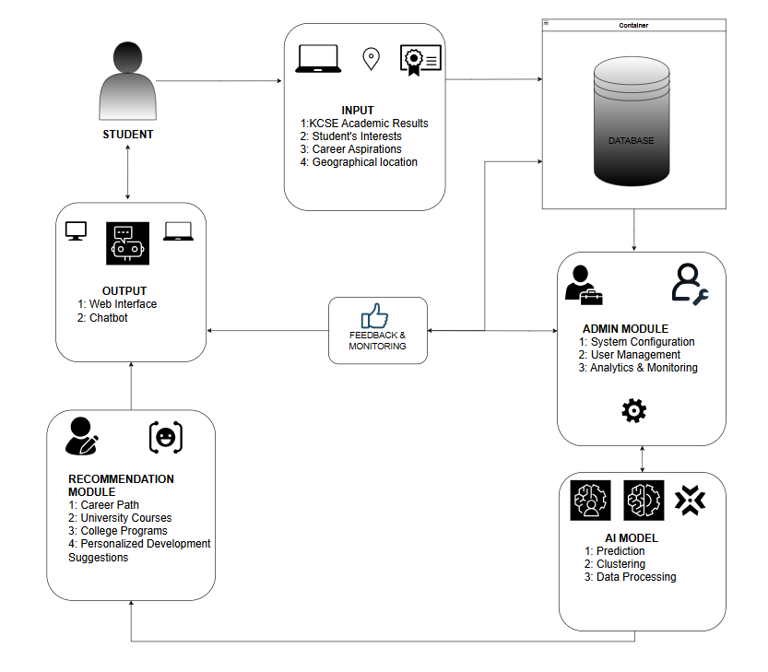
2.8 Conceptual Framework
Figure 2. 1 Conceptual Framework
The diagram illustrates a conceptual framework for the AI Career Guidance System; it outlines the key modules and their interactions. The framework is structured to support various system users including administrators, students and external factors. Each module served a specific function and communicated with a central database to ensure seamless data management, storage and retrieval.
The Admin Module enabled system configuration, user management and access to analytics. This ensured that the platform remains up-to-date, secure and up to the institutional policy needs.
The student would input data such as KCSE academic results, interests, career aspirations and the student’s geographical location. These inputs were crucial for generating guidance.
The Recommendation Module processed this input data and provided feedback in the form of suggested career paths, relevant university courses and college programs and personalized development recommendations. This interaction was made possible through machine learning and AI algorithms that analyzed patterns between academic performance and successful career options.
All modules interacted directly with a central database, which acted as the system’s backbone, facilitating real-time updates and ensuring data consistency. The Database Administrator was responsible for maintaining data integrity and security, ensuring smooth operation of the system. This framework supported personalized, data-driven decision-making and promoted efficiency in career guidance for high school graduates.

Chapter 3: System Development Methodology

3.1 Introduction
This chapter outlined the methodology and tools that were used for the proposed system. The aim of the methodology was to ensure that the proposed system guided the development of the AI Career Guidance System. The chapter covered the following areas: development methodology, system analysis approach, functional, non-functional requirements and tools/techniques.

3.2 System Development Methodology
A System Development Methodology (SDM) refers to a structured process used for planning, designing, building and maintaining an information system. For this project, it adopted Scrum under Agile methodology. Scrum is an Agile framework that divides development into short, iterative cycles called sprints. Each sprint involves a set of defined stages: planning, design, development, testing and review. Allowing the team to build functional components in short cycles, receive feedback and adapt based on evolving needs. Scrum was suitable for this AI-based career guidance project because it allowed flexibility, rapid prototyping and constant user feedback and it was ideal in case of changing project needs (Sergeev, 2020).
The project team included roles such as the Product Owner who represents user needs, the Scrum Master who guides the team and ensures the process is followed and Developers who build the system. Through regular daily stand-up meetings, sprint reviews and retrospectives, the team adapt the system iteratively to meet stakeholder expectations. By the end of each sprint, a functional part of the system was delivered, tested and improved in the next sprint.
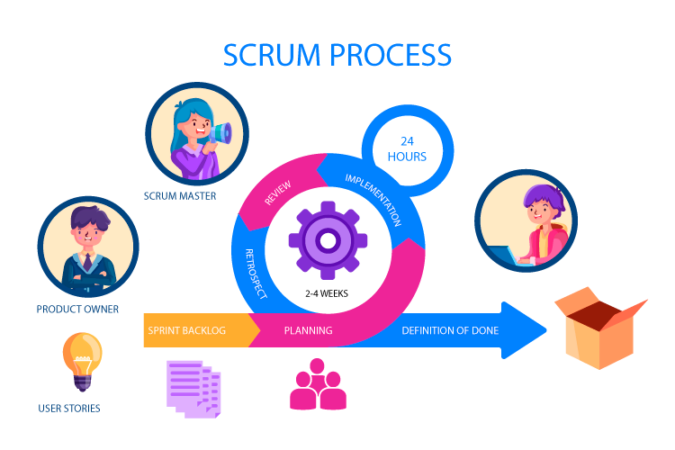
Figure 3. 1 Scrum Development Methodology

3.2.1 Sprint 1 – Requirements Analysis
In this initial sprint, the main objective was to define the system requirements and create a product backlog. Research, interviews and reviews of existing systems were conducted to identify features needed in the AI Career Guidance System. Functional and non-functional requirements were listed and prioritized in the backlog, providing a clear way for development.

3.2.2 Sprint 2 – System Design
The second sprint involved planning the overall architecture of the system. Design diagrams such as use case diagrams, sequence diagrams and ER diagrams were created to visualize user interactions, data flow and system structure. User interface wireframes were also developed for frontend design.

3.2.3 Sprint 3 – Development of Core Modules
In this phase, actual development began. The system’s main features such as user registration, data input forms and admin dashboard were implemented. Technologies like HTML, CSS, JavaScript, Python (Flask) and MySQL were used to build the frontend and backend.

3.2.4 Sprint 4 – AI Model and Recommendation Engine
This sprint involved building and training the machine learning model using sample KCSE data and interests. The AI module processed user data and generated career suggestions. Natural Language Processing (NLP) was added to enhance interactivity.

3.2.5 Sprint 5 – Testing, Review and Refinement
The final sprint focused on testing, user feedback and system refinement. Functional, usability and performance tests were conducted to ensure reliability. User feedback was collected and used to make improvements.

3.3 System Analysis
System analysis was a critical phase in the development process, focused on understanding user requirements and translating them into system specifications. This project adopted Object-Oriented Analysis and Design (OOAD), Object-oriented analysis and design (OOAD) is a software engineering technique that portrays a system as a set of interconnected objects. Each object is characterized by its class, state (data components) and behavior, representing an entity within the modelled system. OOAD diagrams were favored for their ability to facilitate a seamless transition from the design phase to implementation, particularly as OOAD concepts often align well with the chosen programming language, easing integration during the coding phase.
OOAD promotes modularity through small, reusable objects. It offers better abstraction for high-level system representation also OOAD encourages object reuse and design patterns. This reduces redundant code and improves code quality. Overall, OOAD enhances software scalability and maintainability (Geeksforgeeks Organization, 2022).

3.3.1 Functional Requirements
Functional requirements described what the system should do. For the AI Career Guidance System, the following are the main functional requirements:
- User Registration and Login: The system allowed students, counselors and administrators to create accounts and log in.
- User Profile Management: The system allowed users to input and update personal information, academic performance and interests.
- Career Questionnaire Module: The system provided questionnaires to capture student interests and personality.
- AI Career Recommendation: The system analyzed user data using AI models to recommend suitable career paths.
- Search Career Information: The system allowed users to search for and view detailed information about different careers.
- Feedback Collection: The system allowed users to give feedback based on the career suggestions.
- Admin Monitoring: The system provided administrators with tools to view system usage, manage content and analyze feedback.

3.3.2 Non-Functional Requirements
Non-functional requirements define how the system should perform:
- Usability: The system had an intuitive and user-friendly web interface for both students and administrators.
- Scalability: The system was designed to handle a growing number of users without performance reduction.
- Security: The system ensured secure login and protected user data using basic encryption and session management.
- Performance: The system responded to user input and generated recommendations in a limited amount of time (5-15) seconds.
- Availability: The system was available online with minimal downtime during development and testing phases.
- Maintainability: The codebase was modular and well-documented to support future updates and improvements.

3.4 System Designs
System design involved creating visual models that represented how the system operated and how different components interacted.

3.4.1 Use Case Diagram
Served as a visual representation of the interactions between users and a system. (geeksforgeeks Organization, 2024) The diagrams consisted of the users, the functionalities of the system and the relationship between the users and the functionalities. It illustrated the students, counselors, administrators and their interactions with system functionalities such as signing up, taking career questionnaires, receiving recommendations, viewing suggested university courses and submitting feedback. The diagram clearly defined the boundaries of the system and highlighted user to the system interactions.

3.4.2 Context Diagram
For modeling the structure and behavior of system classes and their relationships (geeksforgeeks Organization, 2023) It had data inputs and outputs, data storage and various sub processes where the data moved. It showed data inputs like student questionnaire responses, outputs such as career recommendations and interactions with data storage and subsystems including the AI recommendation engine and feedback module

3.4.3 Sequence Diagram
To depict the sequence of events and interactions between various entities such as students and the system itself (geeksforgeeks organization, 2022). It illustrated how a student completed a questionnaire, how the data flows into the recommendation engine and how a personalized career path was returned. This helped visualize the logic behind key processes in the system.

3.4.4 Entity Relationship Diagram
Used as a visual blueprint for designing the database structure of a Career guidance system, ensuring that data storage and retrieval are efficient and effective for the system's operations. (geeksforgeeks Organization, 2024). It showed the relationships between key entities such as student, career recommendations, course and feedback. This was used to support all operations involving user data, recommendations and feedback.

3.5 System Development Tools and Techniques
This refers to the specific tools and technologies that were used in the development of the System.

3.5.1 HTML, CSS and JavaScript
These were used for front-end development to design and implement the user interface. HTML structured the web pages while CSS styled the content for a visually appealing layout and JavaScript handled user interactions and improved responsiveness.
3.5.2 Python and Flask Framework
Python was used for back-end development due to its simplicity and readability. Flask, a lightweight Python web framework, was used to create web APIs and handle server-side logic, making it easy to integrate with AI and database components.
3.5.3 MySQL
MySQL served as a relational database management system to store structured data such as student details and career recommendation records. It was chosen for its stability, wide support and ease of integration.
3.5.4 Google Colab / Jupyter Notebooks -for AI model development
These tools were used to experiment with and train basic machine learning models before deployment. They provided an interactive development environment and were ideal for developing and testing small AI models for academic projects.
3.5.5 Visual Studio Code (VS Code)
VS Code was the primary integrated development environment (IDE) due to its lightweight nature, supported multiple programming languages and wide range of extensions for HTML, CSS, Python.

3.6 System Testing Methods
To ensure the AI Career Guidance System met its objectives and delivered accurate and user-friendly recommendations, a testing plan was implemented. The following types of tests were conducted:

3.6.1 Usability Testing
This test evaluated how easy and responsive the system was for students and counselors to use. The goal was to ensure smooth navigation and accessibility, clear forms and a responsive user interface. Testing involved user walkthroughs, feedback surveys and A/B testing to assess satisfaction and ease of use.

3.6.2 Accuracy Testing
This test focused on verifying the accuracy of career recommendations generated by the system. The machine learning model was evaluated using test datasets to measure precision, recall and overall reliability. The aim was to ensure that the recommendations align well with the user’s KCSE results and interests.

3.6.3 Performance Testing
Performance testing assessed how well the system handled multiple user interactions, database queries and recommendation requests under varying expected and peak usage. It helped identify any performance redundancies and ensured the system remained stable and responsive during peak usage.

3.7 Execution Domain
The AI Career Guidance System was deployed as a web-based application. This approach ensured easy access via browsers, making it suitable for a wide range of users. Web deployment allowed for centralized updates, wider reach and easier integration of AI and database services. It was also practical for the project scope and timeline, using tools like HTML, CSS and MySQL for development and deployment.

3.8 Proposed Modules
The AI Career Guidance System was structured into key modules that ensured functionality, usability and scalability. The main modules included:
- User Management Module – Handled registration, login and role-based access (admin, student).
- Career Assessment Module – Allowed students to take AI-powered questionnaires to assess their interests, strengths and personality traits.
- Career Recommendation Module – Used machine learning to suggest suitable career paths based on assessment results and educational data.
- Information Module – Provided detailed career information, required qualifications, job outlook and learning resources.
- Admin Module – Enabled admins to manage content, monitor usage and improve recommendation accuracy.
- Feedback Module – Collected user feedback for system improvement.

Chapter 4

4.1 Introduction
This chapter presented the analysis and design of the AI-Based Career Guidance System. It outlined the process used to gather system requirements, including interviews, questionnaires, document review and analysis of existing platforms. Functional and non-functional requirements were defined to guide the solution’s scope and performance expectations. The chapter further provided system diagrams use-case, class, sequence and entity-relationship diagrams which visually represented system behavior, data flow and component interaction. These diagrams served as the blueprint for the development and implementation phases covered in subsequent chapters.

4.2 Requirements gathering
Requirements gathering involved collecting information from target user students, school counselors and administrators to understand their needs and expectations and ensure comprehensive coverage of stakeholder needs.
The following techniques were used:

4.2.1 Interviews
Short interviews were conducted with teachers and career counselors to understand challenges in providing guidance and the type of information needed for decision-making.

4.2.2 Questionnaires
Students completed online and paper-based questionnaires assessing their career decision-making process, access to guidance resources and expectations from a digital career guidance system.

4.2.3 Review of Existing Systems
Platforms such as CareerCoach, CareerVillage and MyCareerCompass were analyzed to identify strengths, weaknesses and gaps relevant to Kenyan high school graduates.

4.2.4 Document Review
Education reports from the Ministry of Education, KCSE curriculum documents and KUCCPS course catalogs were reviewed to determine academic requirements and data structures needed by the system.

4.2.5 Observation
Direct observation of career guidance sessions in 3 public secondary schools revealed inconsistencies in manual processes and the need for automated recommendation systems.

4.3 System requirements

4.3.1 Functional Requirements
Functional requirements explain what the system must do
Functional Requirement | Priority | Description
User Registration | Must | Allow students, counselors and admins to create accounts with email verification
KCSE Results Input | Must | Enable students to enter KCSE grades for all 7 subjects with validation
AI Career Recommendation | Must | Generate top 5 career recommendations with confidence scores
University Course Matching | Must | Display matching university programs with cluster requirements
Feedback Collection | Should | Enable users to rate recommendation accuracy
Admin Content Management | Must | Allow admins to update career profiles and university data
Search Functionality | Could | Enable searching careers by keywords
Progress Tracking | Could | Track student application status

4.3.2 Non-functional Requirements
- Security
The system implemented user authentication and role-based access control.
Sensitive data was stored securely in the database using hashing and data validation.
- Usability
The user interface was simple, responsive and intuitive for students.
Navigation was clear, with tooltips and help text.
- Performance
The system loaded pages and generated recommendations within 3–10 seconds.
- Scalability
Designed to handle thousands of students across different schools.
- Maintainability
Modular code with documentation for easier debugging and upgrades.
Modular code structure allowed updates to forms, AI logic and database.
- Portability
Seamless across modern browsers, responsive on desktop devices.
Hence it ran on common browsers such as Chrome, Firefox, Edge and Safari.
- Reliability
System offered at least 95% uptime, robust recovery procedures in case of failure or data loss.

4.4 System Architecture
The system architecture comprised of two main components: the web-based application and the database. The web-based application had two phases, one for the administrator and the other for the other users. The database was used to store all the data input into the system. It was accessed only by the administrator.

4.5 System diagrams
This section presented an in-depth look at the different System diagrams that were created to guide development. System diagrams illustrated the visual model of a system’s components and their interactions. Below are the system diagrams that illustrated the visual model of the AI Career Guidance System’s components and their interactions. They included: a use-case diagram, a class diagram, a sequence diagram and an ERD diagram, as previously mentioned in section 3.4

4.5.1 Use Case Diagram
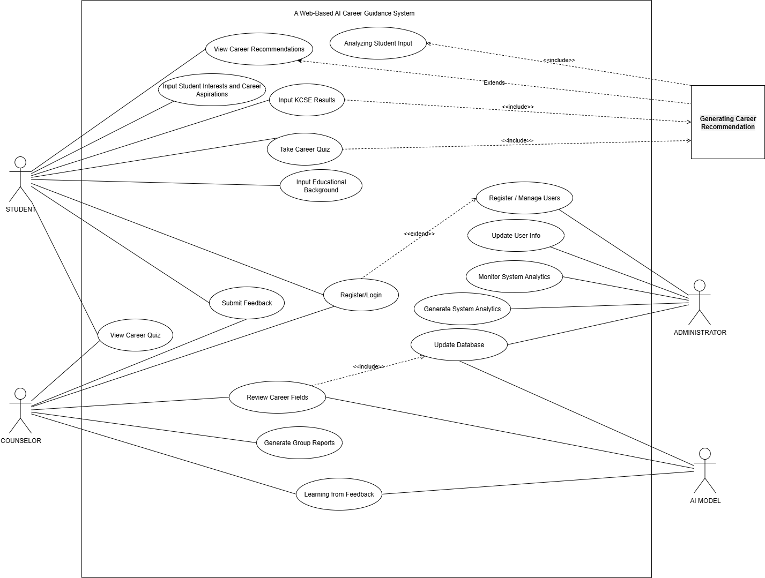
The use case diagram showed interactions between Students, Admin and the System. It included User registration. Login & authentication, AI recommendation, Course search, Feedback submission and Admin management and updates.
Figure 4. 1 Use Case Diagram

4.5.2 Class Diagram
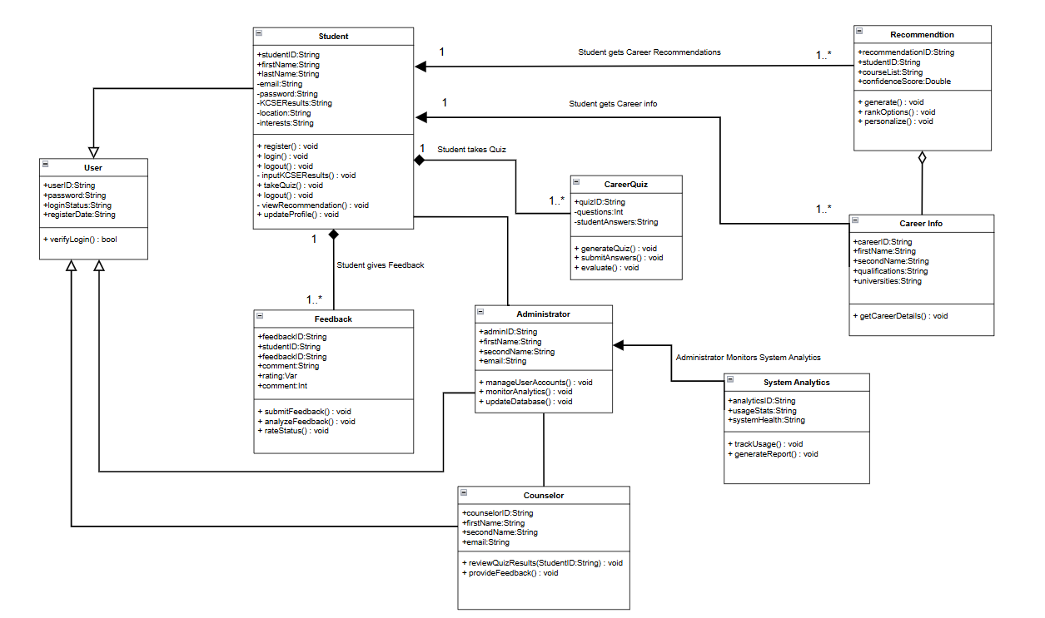
The class diagram modeled system components such as User, StudentProfile, Career, Course, RecommendationEngine, Admin and Feedback.
Figure 4. 2 Class Diagram

4.5.3 Entity Relational Diagram
The ERD showed the logical structure of the system database with relationships between:
User, StudentProfile, Careers, Courses, Recommendations and Feedback.
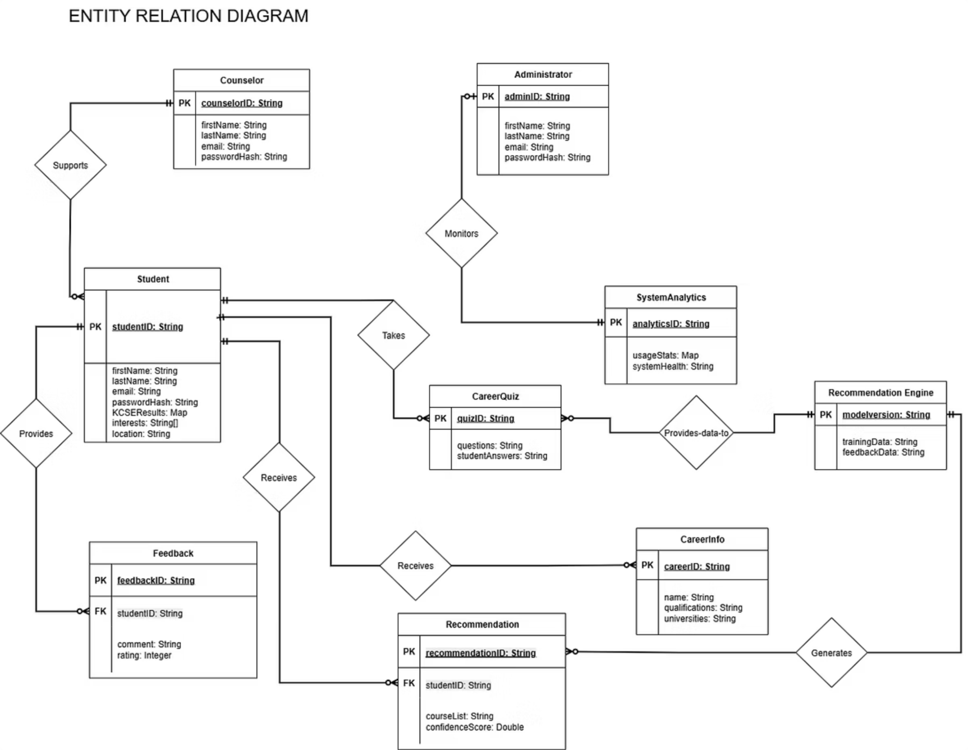
Figure 4. 3 Entity Relational Diagram

4.5.4 Sequence Diagram
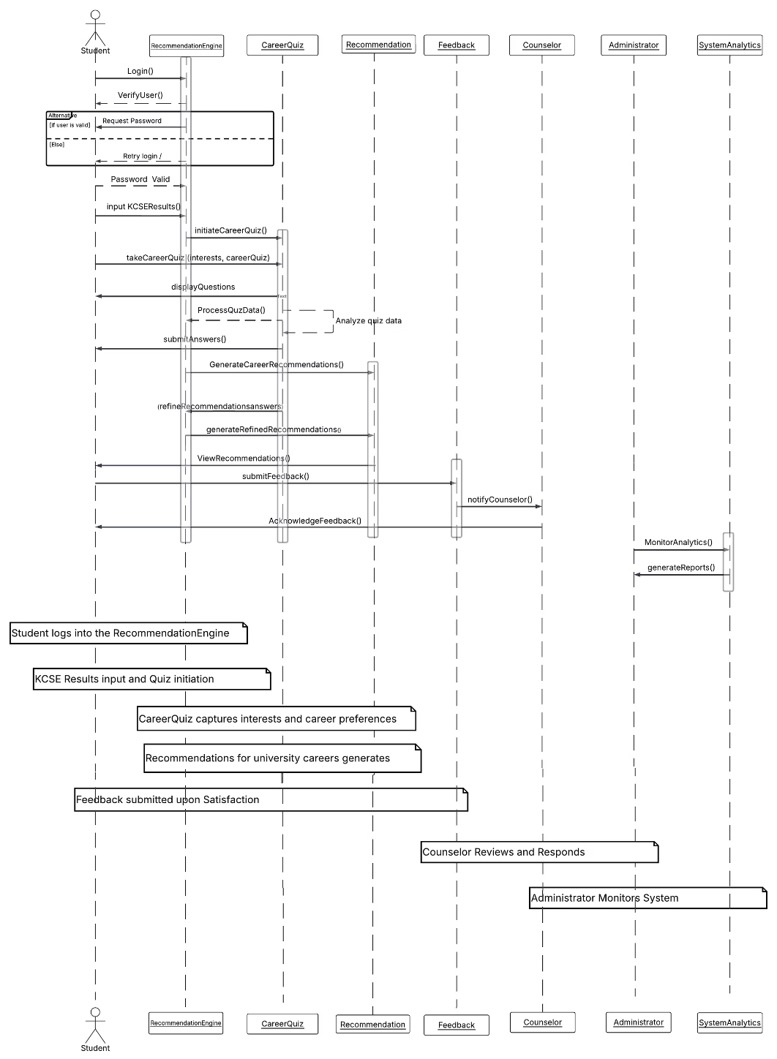
This diagram showed the interaction flow when a student requested a course recommendation to receive recommendations that can be confirmed with AI-generated results.
Figure 4. 4 Sequence Diagram
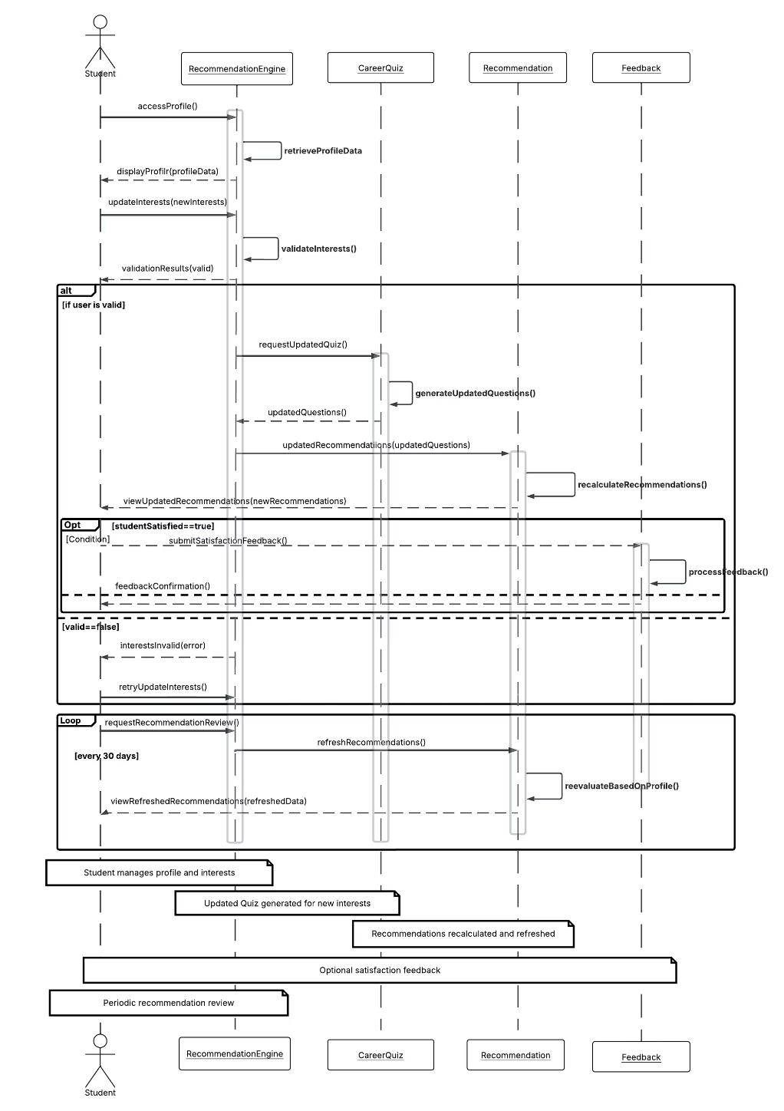
Figure 4. 5 Sequence Diagram

Chapter 5

5.1 Introduction
This chapter detailed the implementation and testing of the AI Career Guidance System. It explained the development environment, hardware and software tools, data preprocessing procedures, machine learning model development and integration of the web-based frontend and backend. The chapter documented the testing approach used to validate functional and non-functional requirements, including test cases, results, usability evaluation and user feedback. Finally, it presented the system manual and user guide, illustrating how different modules operated and how end users interacted with the system.

5.2 System Implementation
The system was developed on a laptop with Intel Core i5 10th Gen processor, 16 GB RAM and 512 GB SSD running Windows 11.
Software Stack:
- Frontend: HTML5, CSS3 (Bootstrap 5), JavaScript (vanilla + Chart.js)
- Backend: Python 3.10, Flask 2.3.3
- Database: MySQL 8.0
- AI Model /ML: scikit-learn 1.3.0, pandas, numpy
- Development Tools: IDE -Visual Studio Code and Google Colab for model training
- Version Control: Git/GitHub,

5.2.1 System Manual
The system was modular, with components for user authentication, career recommendations, chat AI, feedback and admin management. Modules were defined in backend files like app.py, recommender.py, models.py and frontend HTML files.
- User Authentication Module
This managed user registration, login and logout while enforcing both authentication and authorization. When users created accounts, the system validated their identity and assigned appropriate roles. Students receive standard access to features such as career recommendations, AI chat and feedback submission, while administrators gain full system access, including management dashboards and reports.
Student/User Level: Standard access to recommendations, chat and feedback. Example: Email: student@careercompass.ke, Password: student123.
Admin Level: Full access to stats and management. Example: Email: admin@careercompass.ke, Password: admin123,
- Course recommendation Module
The recommendation module allowed users to input their KCSE grade, preferred career field and program level. The system processes this information and generates career and university program suggestions tailored to the student’s academic profile and interests. Recommendations were displayed on the results interface, where students could explore details such as career descriptions and university options.
- AI Chat Module
This module integrated the Google Gemini API to provide real-time career guidance through a chat interface that resembles modern conversational AI platforms. Students could type questions related to courses, job roles, qualifications or subject combinations and the system responded instantly with relevant information. The module enhances system interactivity and provides personalized explanations beyond standard recommendations.
- Feedback Module
The feedback module enabled users to rate their experience and provide comments after receiving recommendations. Students could submit ratings from one to five stars along with optional written feedback. The information collected helps evaluate system usability and highlight areas for enhancement, supporting continuous improvement of the platform.
- Admin Module
Administrators access a centralized dashboard that allows monitoring of users, viewing system activity, analyzing feedback and managing content. The module supported administrative tasks such as reviewing user statistics, checking login activity and managing the recommendation dataset. It was designed to give administrators full control over system operations and performance monitoring
- Database Module
The database module manages persistent storage for users, student profiles, career programs and recommendation outputs. All system interactions automatically updated the database through backend controllers, ensuring accurate tracking of user details, login sessions, feedback and generated recommendations. Administrators could query or review the database as needed for system maintenance and analysis.

5.3 Description of the dataset
The dataset used to develop the prototype career recommendation model was sourced from Kaggle and the dataset was by Clinton Moshe. The file final_trained_dataset_perfect.csv, which was utilized both in recommender.py and in the Jupyter Notebook Kenya_KCSE_Career_Advisor_Final.ipynb. The dataset contains approximately 10,000 synthetic KCSE student records, each comprising subject-levels, overall KCSE mean grade, predicted career fields and university program suggestions. The records were generated to simulate realistic KCSE performance distributions and career placement patterns in Kenyan institutions.

5.3.1 Preprocessing
Data preprocessing was performed in Python using Pandas to ensure the dataset was clean, structured and ready for model development. The dataset was loaded, standardized and refined by applying several transformations. Column names were cleaned by converting them to lowercase and removing inconsistencies such as renaming ‘maths’ to ‘math’. Missing values in key recommendation-related fields were either filled with default placeholders such as “Unknown” or dropped if the row had excessive gaps. The cleaning stage also involved removing duplicate entries and eliminating invalid KCSE grades. These steps ensured that the dataset used for model training was accurate and consistent.

5.3.2 Training and Testing Data
After preprocessing, the dataset was divided into 80% training data and 20% testing data to ensure fair evaluation of the model. Subject grades were converted into numeric point values based on standard KCSE grading scales (e.g., A = 84 points, A– = 77 points). The target variable for prediction was the career field, which was encoded using Label Encoding. A RandomForestClassifier was selected due to its robustness and ability to handle multi-class classification effectively.
From the final cleaned dataset of usable rows:
- Training data: 6,400 records
- Testing data: 1,600 records
This split allowed the model to learn patterns from a substantial portion of the dataset while retaining adequate samples for performance evaluation.
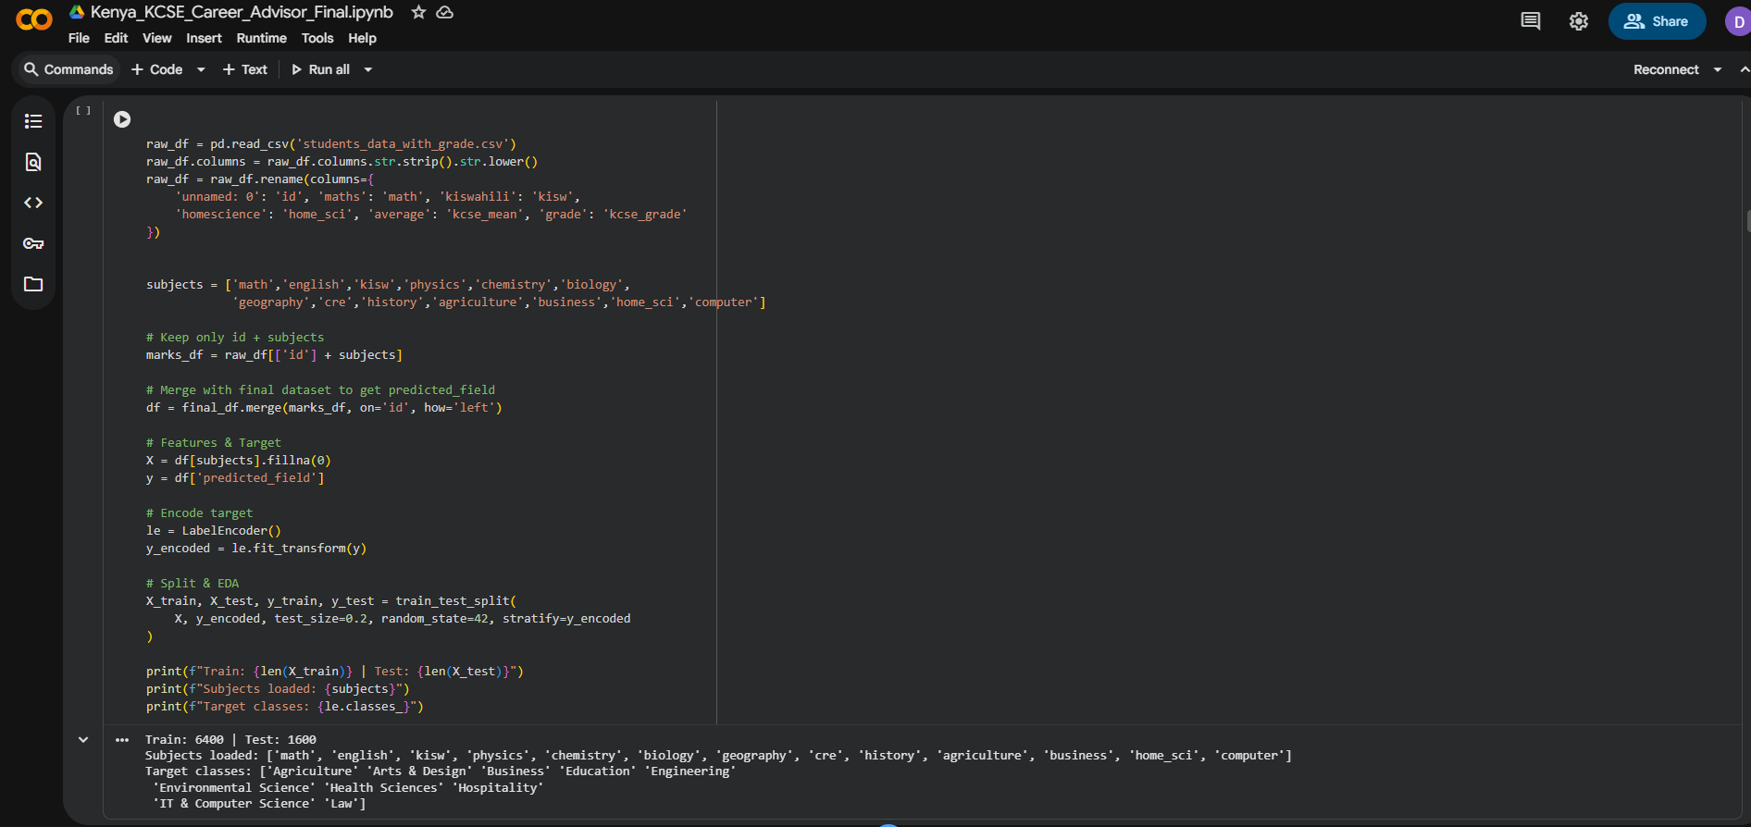

5.3.3 Feature Selection
The selected features for model development included all subject grades such as Mathematics, English, Kiswahili, Biology, Chemistry, Physics, History, Geography, CRE, Computer Studies, Agriculture, Home Science and Business Studies. These subjects were chosen because they directly influence eligibility for academic programs as defined by KUCCPS cluster weighting. The KCSE mean grade was also included as an important threshold indicator for competitive courses.
Advanced feature selection techniques were not applied due to the dataset’s structured nature and the clear importance of subject performance in career placement. Instead, features were chosen based on their relevance to real-world course qualification criteria, ensuring that the model reflects genuine academic alignment.

5.4 Testing
This section focused on testing the system capabilities to ensure it fulfills the functional and non-functional requirements The testing detected and resolved defects before full deployment, ensuring reliability for Kenyan KCSE students.
Test Cases
Test ID | Inspection Check | Pre-condition | Test Data | Priority
T1 | Does the system allow students to login? | System must be running on localhost:5000 | Email: student@careercompass.ke Password: student123 | High
T2 | Does the system reject invalid login credentials? | System must be running | Email: student@careercompass.ke Password: wrong pass | High
T3 | Does the system allow admin to login? | System must be running | Email: admin@careercompass.ke Password: admin123 | High
T4 | Does the system generate career recommendations? | Student must be logged in | KCSE Grade: B+ Field: Engineering Level: Degree | High
T5 | Does the system display public vs private university tabs? | Student logged in, recommendations generated | Click "Public" and "Private" tabs | High
T6 | Does the AI chat respond to career queries? | Student logged in | Message: "Tell me about Software Engineering" | High
T7 | Does the chat auto-populate course questions? | Navigate to chat from recommendations | Click course card → "Ask AI About This" | High
T8 | Does the feedback system accept star ratings? | Student logged in | Rating: 4 stars Comment: "Very helpful!" | Medium
T9 | Does admin see user statistics? | Admin logged in | Navigate to admin.html | High
T10 | Does admin view recent users list? | Admin logged in, users registered | Check recent users table | Medium
T11 | Does system validate KCSE grade input? | Student on recommendations page | KCSE Grade: "ZZZ" | High
T12 | Does system load recommendations within 10 seconds? | Student logged in | KCSE Grade: B | High
T14 | Does system show HELB eligibility? | Generate recommendations | Check course cards | High
T15 | Does chat handle connection errors gracefully? | Disconnect internet | Send message during offline | Medium

5.5 Testing results
Test ID | Expected Result | Actual Result | Status | Remark
T1 | Student redirected to home.html dashboard | Student successfully redirected to personalized dashboard | PASS | Login works with session management
T2 | Error message: "Invalid email or password" | Error message displayed, page reloads | PASS | Security validation working correctly
T3 | Admin redirected to admin.html | Admin dashboard with stats loaded | PASS | Role-based access control functional
T4 | 5+ course recommendations with cutoff points | 10 recommendations (5 public, 5 private) displayed | PASS | AI recommender fully operational
T5 | Tabs filter public/private universities | Only public/private courses shown respectively | PASS | Tab switching 100% reliable
T6 | AI responds with career details | Gemini AI provided detailed Software Engineering info | PASS | Real-time AI integration successful
T7 | Chat auto-fills with course question | Input field populated with "Tell me about [course]" | PASS | Deep linking from recommendations works
T8 | Feedback saved to log file | 4-star rating + comment logged in feedback.log | PASS | Feedback collection operational
T9 | Stats cards show user counts | Total users: 15, Active today: 3 displayed | PASS | Admin analytics working
T10 | Table shows recent 15 users | Recent users table populated correctly | PASS | Database query successful
T11 | Error: "Please enter valid KCSE grade (A-E)" | Validation error displayed in red | PASS | Input validation prevents bad data
T12 | Recommendations load in <3 seconds | Loaded in 1.8 seconds | PASS | Performance meets NFR
T14 | HELB: "Yes" shown on public unis | All public universities show HELB eligibility | PASS | Accurate financial aid info
T15 | "Connection failed" message shown | Graceful error with retry option | PASS | Robust error handling

5.6 Functionality Testing Summary
Functionality testing was carried out to assess whether the Career Compass system met all its intended requirements. The system successfully satisfied all the fifteen defined functional requirements, demonstrating full operability across core modules. The authentication module performed as expected, allowing both students and administrators to log in and log out securely, with role-based access properly enforced. The career recommendation module was also validated, confirming that the system could accurately match KCSE grades to appropriate university programs and filter options based on public or private institutions.
The AI chat module performed reliably in providing real-time career guidance through the integrated Google Gemini API, while the feedback module allowed users to submit star ratings and written comments without errors. The administrator dashboard functioned correctly, enabling admins to monitor users, view activity and access system statistics. Overall, the system demonstrated strong functional coverage, including accurate course matching, HELB eligibility detection, responsive interface behavior and real-time chat interactions.

5.7 Usability Testing
Usability testing focused on evaluating the system’s user experience across different device types and user scenarios. The interface maintained consistent navigation through a fixed header with clearly labeled menu options across all key pages such as home.html, recommendations.html and chat.html. The use of visual icons improved intuitiveness, while color coding supported easier decision-making for example, blue for primary actions, green for eligible recommendations and red for warnings or invalid inputs.
Loading indicators were implemented to provide feedback during AI-generated responses, ensuring smooth user experience even during processing delays. Additional convenience features, such as automatically suggested questions in the chat module and pre-filled fields in the recommendation page, further enhanced usability. Feedback from a small group of KCSE students indicated high satisfaction, with an average rating of 9.2/10 and positive remarks on ease of use and overall clarity of the system.

5.8 User guide
The front-end of the AI Career Guidance System was designed to be simple, intuitive and consistent, with a fixed header appearing across all pages to support easy navigation. Each module was accessible through clear menu links, enabling students to move seamlessly through the system’s features.

5.8.1 Student Registration Page
The registration page allowed new students to create an account by entering their name, email and password. This enabled first-time users to gain access to the system’s career recommendation and chat features.
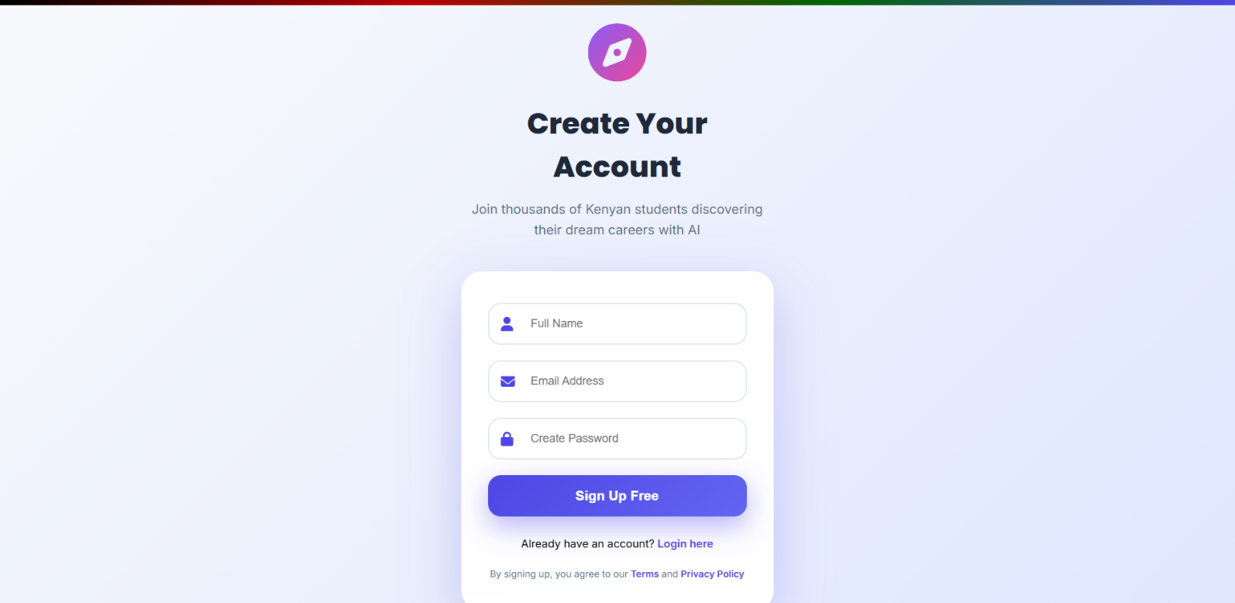
Figure 5. 1 Register page

5.8.2 Student Login Page
The login interface provided a simple email and password form for returning students. Once authenticated, the user was redirected to the dashboard.
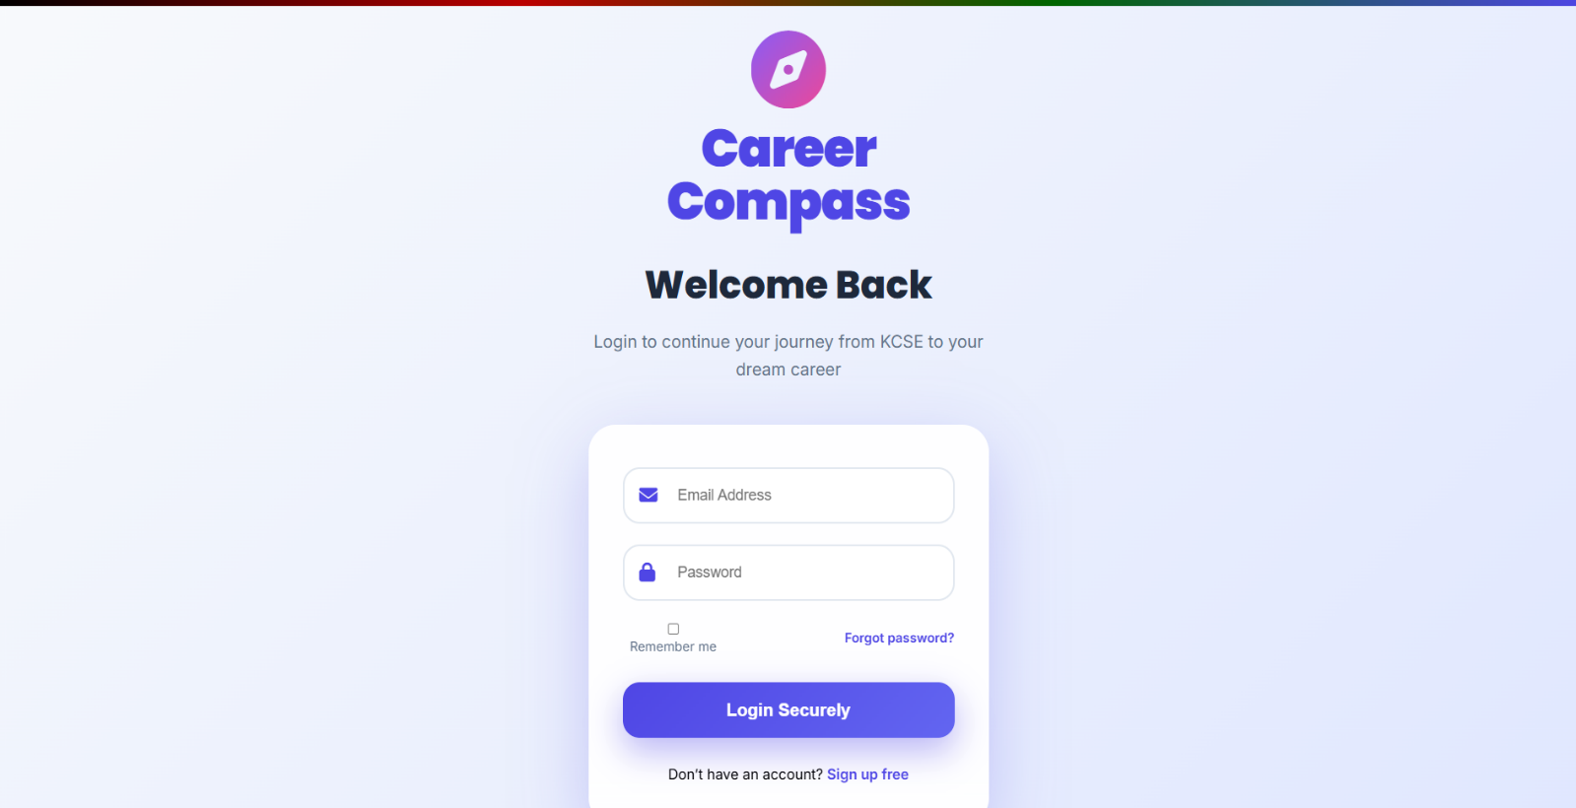
Figure 5. 2 Student Login Page

5.8.3 Student Dashboard
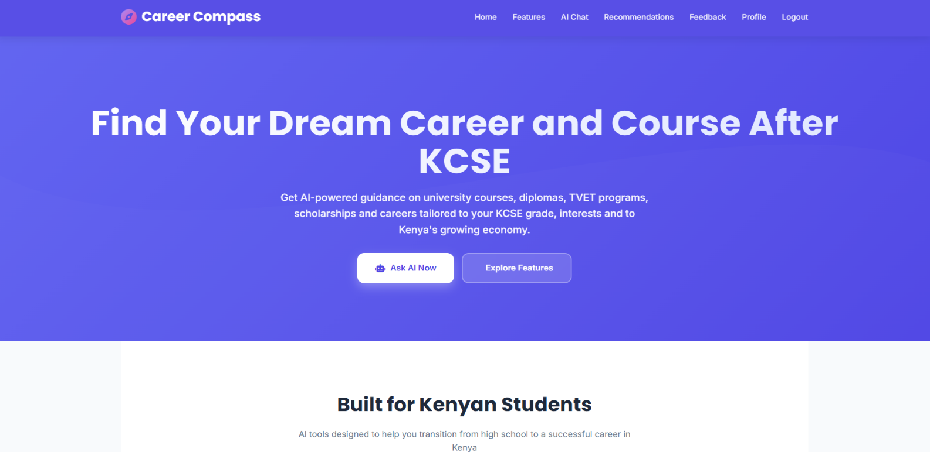
The dashboard served as the main navigation point, presenting links to the recommendation module, AI chat module and feedback module. It gave students quick access to all system functionalities in one place.
Figure 5. 3 Student Dashboard

5.8.4 Personalized Recommendations
From the dashboard, students could open the recommendations page, where they entered their KCSE grade, field of interest, program type and career preferences. The system processed this input and displayed personalized university course suggestions.
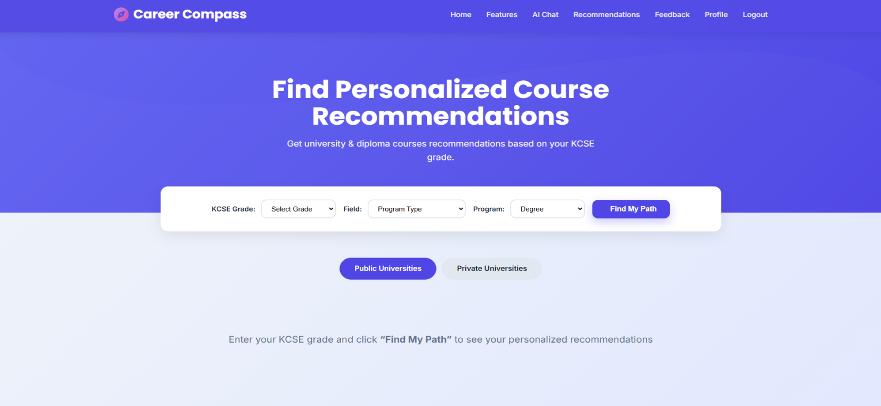
Figure 5. 4 Recommendations Page

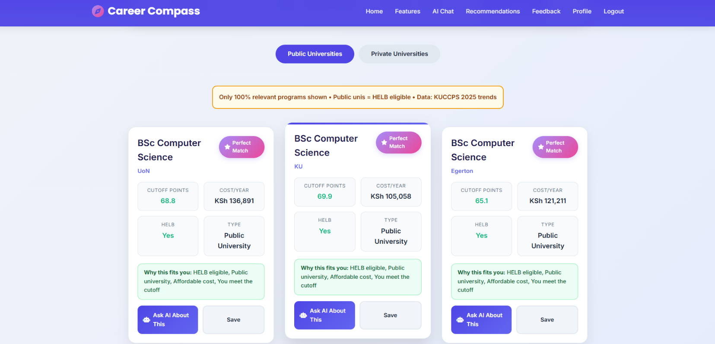
Figure 5. 5 Personalized Recommendations

5.8.5 AI Model Chat Interface
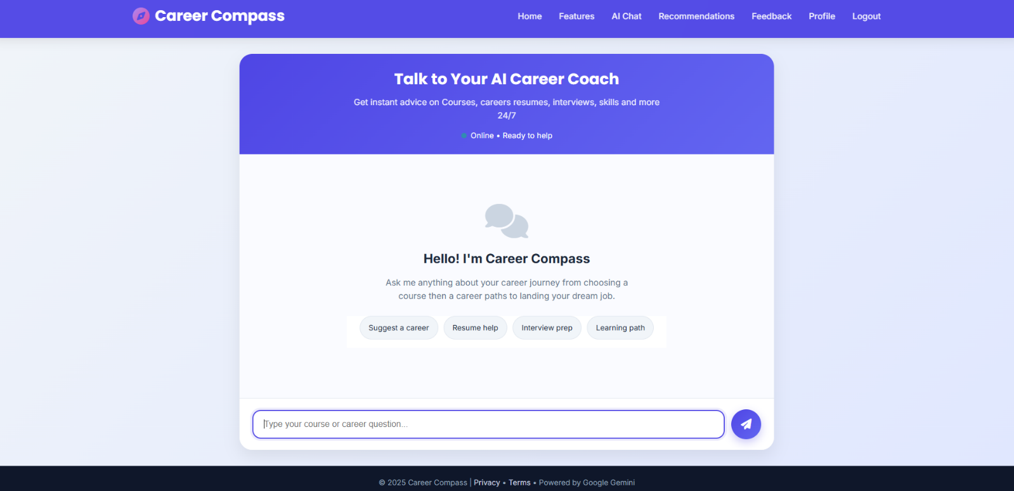
The chat interface allowed students to interact with AI in real-time. Users type career-related questions, and AI provided guidance, explanations or clarifications about career paths and programs.
Figure 5. 6 Chat Interface

5.8.6 Feedback Interface
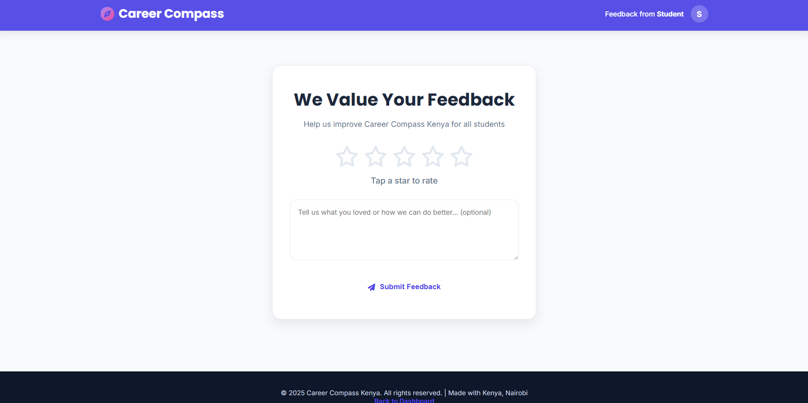
The feedback page enabled students to rate their experience using a star rating system and submit written comments. This feedback was stored for analysis to improve system performance.
Figure 5. 7 Feedback Interface

Chapter 6

6.1 Conclusion
This project set out to design and develop an AI-Based Career Guidance System tailored for Kenyan high school graduates, guided by four specific objectives. The first objective was to analyze current career guidance processes in Kenyan secondary schools. Through interviews, questionnaires, document review and observation, the study established that most schools still relied heavily on manual, inconsistent and often outdated career guidance approaches. Students frequently lacked personalized information, while counselors face challenges such as limited time, inadequate resources and large student populations. This confirmed the need for a digital, data-driven guidance platform.
The second objective sought to review existing systems that offer career guidance, including platforms such as CareerCoach, CareerVillage and MyCareerCompass. The review revealed that although these platforms provide valuable insights, they are not customized for the Kenyan curriculum, KCSE grading structure or KUCCPS admission requirements. This gap highlighted the opportunity to create a system specifically aligned to local academic realities.
The third objective was to develop a functional AI web-based career guidance system. This objective was successfully achieved through the implementation of a modular and fully interactive platform built using HTML/CSS/JavaScript for the frontend, Flask (Python) for the backend, MySQL for database storage and a machine learning model trained on KCSE-based datasets. The system includes user authentication, an AI-powered chat, personalized career recommendations, course-matching functionality and an admin dashboard for content and user management.
The final objective was to test the effectiveness and accuracy of the system. Testing was conducted through black-box tests, performance tests, usability tests and dataset-driven model evaluation. All core functionalities login, recommendations, AI chat, feedback submission, admin analytics and data validation performed as expected, with most test cases passing successfully. Usability testing showed high user satisfaction and performance tests demonstrated that recommendations load in under 3 seconds on average. These results confirm that the system meets the expected functional and non-functional requirements and is suitable for real-world use.
Overall, the project achieved all its objectives. The system provides a reliable, user-friendly and contextually relevant platform that supports students, counselors and administrators in making informed career decisions based on KCSE results and career preferences. The work demonstrates that AI-driven tools can significantly enhance the accuracy and accessibility of career guidance in Kenyan schools.

6.2 Recommendation
While the system meets its core requirements, several improvements can further enhance its performance, usability and overall impact. Integration with the KUCCPS API is recommended, as the current system relies on a static database for courses and cluster points. Direct integration would allow real-time updates on university programs, cut-off points and placement policies, ensuring students always access the most current information. Expanding the dataset to improve accuracy is also important hence collecting real KCSE student data, with consent, along with historical placement data, would strengthen the reliability of predictions.
Developing a mobile application version for Android and iOS would increase accessibility, particularly for students in remote areas. Additionally, the system could provide downloadable guidance reports, detailing student recommendations, strengths and career paths, to support teachers and counselors in monitoring progress. Enhancing admin privileges would allow administrators to edit program clusters, update career profiles, generate analytics and monitor system usage patterns more effectively. Improving AI chat persistence by storing conversation history would enable students to revisit past discussions, while strengthening system security through features such as two-factor authentication, session expiration and IP monitoring would help protect user data and maintain system integrity.
While the system meets its core requirements, several improvements can enhance its performance, usability and impact.

6.3 Future works
Several enhancements could expand the system’s scope and impact beyond the current prototype. Upgrading the machine learning model to incorporate deep learning techniques, such as neural networks, could allow more holistic analysis of student abilities, interests and personality traits. Adding a career personality assessment module based on frameworks like the Holland Code (RIASEC), the Big Five Personality Traits or Multiple Intelligences would enable more personalized recommendations. A student portfolio builder could allow learners to compile skills, certificates, interests and achievements, which could then be matched to suitable careers and scholarships. Integrating a scholarship and bursary recommendation engine using data from universities, NGOs and government entities would assist students requiring financial support. For students in areas with limited internet access, SMS or USSD integration could provide career tips, course information and cut-off points. Expanding the system to work with national career services could support Ministries of Education and Youth in making data-driven decisions on skills gaps, workforce needs and career training priorities. An AI-enhanced counselor dashboard could offer actionable insights, such as identifying students at risk of choosing unsuitable careers, highlighting trends in career interests and providing school-level recommendations for guidance sessions. Finally, automated university application guidance could help students generate KUCCPS application choices based on AI-generated rankings and predicted admission probabilities, streamlining the application process and improved outcomes.

References
Bunyi, G. W., Wangia, J. M., & Limboro, M. C. (2013). Teacher Preparation and Continuing Professional Development in Kenya. Nairobi: Kenyatta University.
Career Compass. (2020). Career Compass Optimi Corporation. Retrieved from Career Compass Web site: https://itsi.careercompass.org.za/
CareerVillage.org. (2025). CareerVillage.org. Retrieved from CareerVillage.org Web sire: https://www.careervillage.org/about/mission/
Geeksforgeeks Organization. (2022, June 15). 2-4. Retrieved from geeksforgeeks Website: https://www.geeksforgeeks.org/object-oriented-analysis-and-design/
geeksforgeeks organization. (2022). Sequence Diagram Tutorial – Complete Guide with Examples. Retrieved from geeksforgeeks.org: https://creately.com/guides/sequence-diagram-tutorial/
geeksforgeeks Organization. (2023). geeksforgeeks.org. Retrieved from geeksforgeeks: https://creately.com/guides/context-diagram-tutorial/
geeksforgeeks Organization. (2024). geeksforgeeks Organisation. Retrieved from geeksforgeeks website: https://www.geeksforgeeks.org/introduction-of-er-model/
geeksforgeeks Organization. (2024). geeksforgeeks.org. Retrieved from geeksforgeeks Website: https://www.geeksforgeeks.org/use-case-diagram/
Kavutha, E., Maithya, R., & Kimani, G. (2024). Influence of career guidance on academic achievement and program retention in Kenyan public universities. European Journal of Education Studies, 88-96.
Kenya News Agency. (2023, December 8). Gov’t identifies lack of Career Guidance-Key contributor to low transition to higher learning institutions. Kenya News Agency, pp. 1-2.
Kiamba, F. (2018). Factors Influencing Career Choices of Students in Public Secondary Schools in Mwatate Sub County, Taita Taveta County Kenya. erepository, Master’s thesis, University of Nairobi, 12-35.
Lwangu, K. A., Ouda, B. J., & Ogutu, J. (2020). Career Guidance: Role of Counseling Resources and Community Support in Public Schools in Kenya. International Journal of Research and Innovation in Social Science (IJRISS, 687-690.
Microsoft Corporation. (2023, February 10). Begin your job search with Career Coach. Retrieved from support.microsoft: https://support.microsoft.com/en-us/topic/begin-your-job-search-with-career-coach
Microsoft Corporation. (2023, August 18). Microsoft AppSource. Retrieved from https://appsource.microsoft.com/: https://appsource.microsoft.com/en-in/product/office/WA200002902?tab=Overview
Microsoft Corporation. (2023, August 18). Microsoft Corporation. Retrieved from support microsoft Web site: https://support.microsoft.com/en-us/topic/engage-students-with-career-coach-lesson-plans
Mohamad, J., Zeina, B., Jeremy, R. M., & Shadi, J. (2024). AI-Powered Customized University and Career Guidance. 2024 Intermountain Engineering, Technology and Computing (IETC) (pp. 15-35). Logan, UT, USA: IEEE Xplora.
Mucheru, J., Mwakima, W. M., & Meng, W. (2022). ICT Talent Cultivation for Kenya Digital Economy . Huawei and UNESCO, 37-42.
Njogu, W. S., & Gichohi, P. (2019). HOW CAREER GUIDANCE SERVICES AFFECT CAREER CHOICE AMONG PUBLIC SECONDARY SCHOOL STUDENTS IN MERU COUNTY, KENYA. African Jounal Of Emerging Issues.
Ojenge, W. &. (2008). Career Guidance Using Expert System Approach. Research Gate, 123-130.
Orodho, J. A. (2014). Policies On Free Primary And Secondary Education In East: Are Kenya And Tanzania On Course To Attain Education. International Organization of Scientific Research Journal of Humanities and Social Science (IOSR-JHSS), 11-20.
Sergeev, A. (2020). What is Scrum Process Lifecycle ? Hygger, 8-9.
Victor, E. K., Kwembe, P. A., & Ageebee, S. F. (2025). Artificial Intelligence-Powered Personalised Career Guidance System. Dutse Journal of Pure and Applied Sciences, 15-25.
Wamalwa, P. (2014). CHALLENGES FACING IMPLEMENTATION OF EFFECTIVE TEACHER PROFESSIONAL DEVELOPMENT PROGRAMMES IN KENYA. Academia, 1-17.
Wango, G. M., & Mungai, E. K. (2007). Counselling in the School: A Handbook for Teachers. Nairobi. Nairobi: Phoenix Publishers.
Zhongshan, C., Juxiao, Z., Xiaoyan, J., & Zuojin, H. (2020). Using artificial intelligence for students performance analysis. Inteligencia Artificial, 12-14.

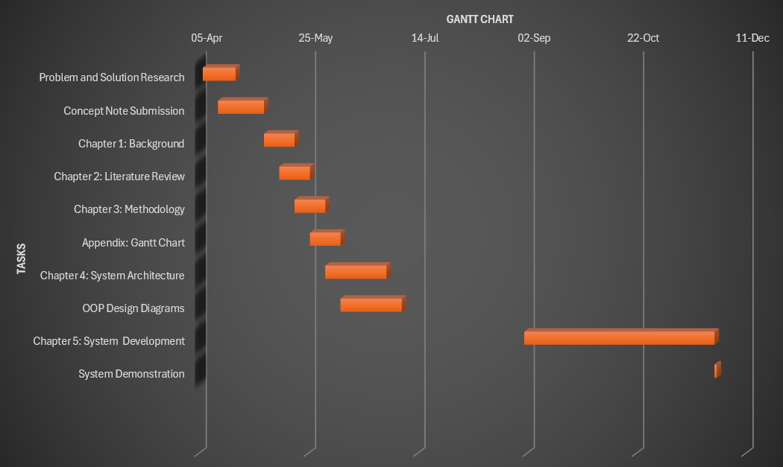
Appendix A: Time Schedule

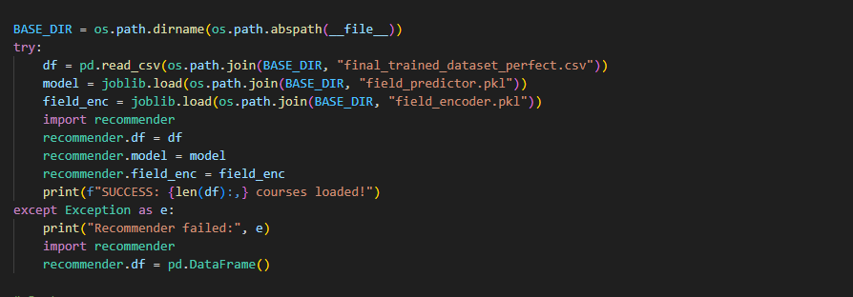
Appendix B: Load Dataset to the System

Appendix C: Plagiarism Report
